National University of Computer and Emerging Sciences



Laboratory Manual

for

Programming Fundamentals

|  |  |
| --- | --- |
| Course Instructor | Mr. Waqas Manzoor |
| Lab Instructor(s) | Miss Shazia Ahmed  Mr. Adeel Qayyum |
| Section | PF E |
| Semester | Fall 2020 |

Department of Computer Science

FAST-NU, Lahore, Pakistan

Arithmetic binary operator:

|  |  |
| --- | --- |
| Operations | Answer |
| Int divided by int | int |
| Foat divided by float | Float |
| Double divided by double | Double |
| Int divided by float | float |

## Practice Questions.

1. Implement the following equations and check results.  
   int a, int b, float c, double d;
   1. a/b
   2. b/c
   3. c/d
   4. a/d

# Lab Manual 04

**Problem 1:**

You have to develop a program which approximates salary of a candidate for a certainjob. Salary depends upon its qualification and experience in related field. Only malecandidates with age more than 25 years are preferred for this job. If candidate is a freshgraduate, salary will be in range of 25-40K, but if his qualifications are MS or PhD, thenperson with experience of more than 5 years will get salary 70k+ otherwise 40k to 70k.

**Sample Output:**

Enter age: 28

Enter experience in years: 3

Gender (M for male, F for female): M

Qualification (1 for BS, 2 for MS, 3 for PhD)

Your salary is: 75000

**Problem 2:**

Write a C++ program of a Body Mass Index (BMI) calculator application that reads the user’s weight and height and then calculates and displays the user’s body mass index. The formula for calculating BMI is: BMI = (Weight in Kilograms / (Height in Meters x Height in Meters)) Also, the program should display the following information from the scale provided below. For the calculated BMI VALUES Underweight: less than 18.5; Normal: between 18.5 and 24.9; Overweight: between 25 and 29.9; Obese: 30 or greater Note: Your program should check that the height and weight entered are not negative. If the entered data is incorrect display a message accordingly.

Example:

Height= 1.7

Weight in kilogram= 65

**Output:**

BMI=22.5

Normal on BMI scale

Height= 1.53

Weight in kilogram= 72

**Output:**

BMI=30.7

Obese on BMI scale

**Problem 3: Use nested if…..else (Your solution without nested if will not be considered)**

Write a program to find the price of the pizza per square inch. Equation to calculate area is

𝐴𝑟𝑒𝑎 = 𝜋*(𝑟*r)

The flavor, radius and their price is as follow:

|  |  |  |  |
| --- | --- | --- | --- |
| Flavor | 6 inches | 9 inches | 12 inches |
| Tikka | Rs:800/- | Rs:900/- | Rs:1000/- |
| Fajita | Rs:700/- | Rs:800/- | Rs:900/- |
| Supreme | Rs:1000/- | Rs:1200/- | Rs:1400/- |

Ask if it’s customer’s birthday? If it is, then they get a 10% discount. (Do not use logical operators)

**Sample output:**

Select size (6, 9 or 12 inches): 9

Select Flavor (T: tikka, F: fajita, S: Supreme): F

isYour Birthday(Y: yes, N: no): N

Price per square inch: 0.3 rupees

**Problem 4:**

A box of cookies can hold 35 cookies, and a container can hold 150 boxes of cookies. Write a program that prompts the user to enter the total number of cookies, the number of cookies in a box, and the number of cookie boxes in a container. The program then outputs the number of boxes and the number of containers to ship the cookies. Note that each box must contain the specified number of cookies, and each container must contain the specified number of boxes. If the last box of cookies contains less than the number of specified cookies, you can discard it and output the number of leftover cookies. Similarly, if the last container contains less than the number of specified boxes, you can discard it and output the number of leftover boxes.

**Sample Output:**

Enter number of cookies: 1250

Enter cookies per box: 20

Enter boxes per container: 10

Number of boxes: 62 boxes and 10 cookies

Number of containers: 6 Containers and 2 boxes

**Problem 6:**

Write a C++ program that reads an ‘n’ number then finds and prints the sum of even and odd integers up to nth number. (Use While loop)

**Sample Output:**

Enter nth number: 10

Sum of evens = 30

Sum of odds = 25

**Problem 7: (use While loop)**

Print the Fibonacci sequence (0,1,1,2,3,5,8,13,21,34,…) till the N member. Take N from user input. Fibonacci sequence is given by formula: sum the last two numbers to get the current.

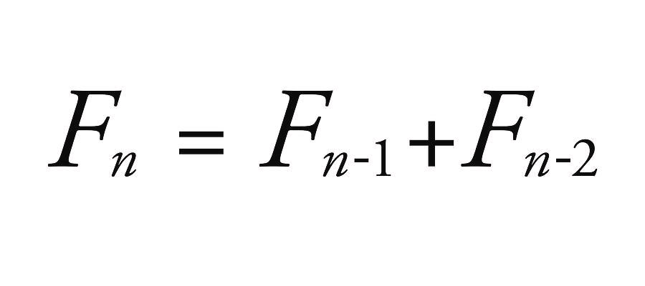

***Sample Output:***

Enter nth number: 10

0,1,1,2,3,5,8,13,21,34

**Problem 8:**

The factorial of a positive integer n is equal to 1*2*3*...n. You will learn to calculate the factorial of a number using While loop.

***Sample Output:***

Enter nth number: 7

1*2*3*4*5*6*7 = 5040